WEB TECHNOLOGIES
ASSIGNMENT 2

PROGRAM:
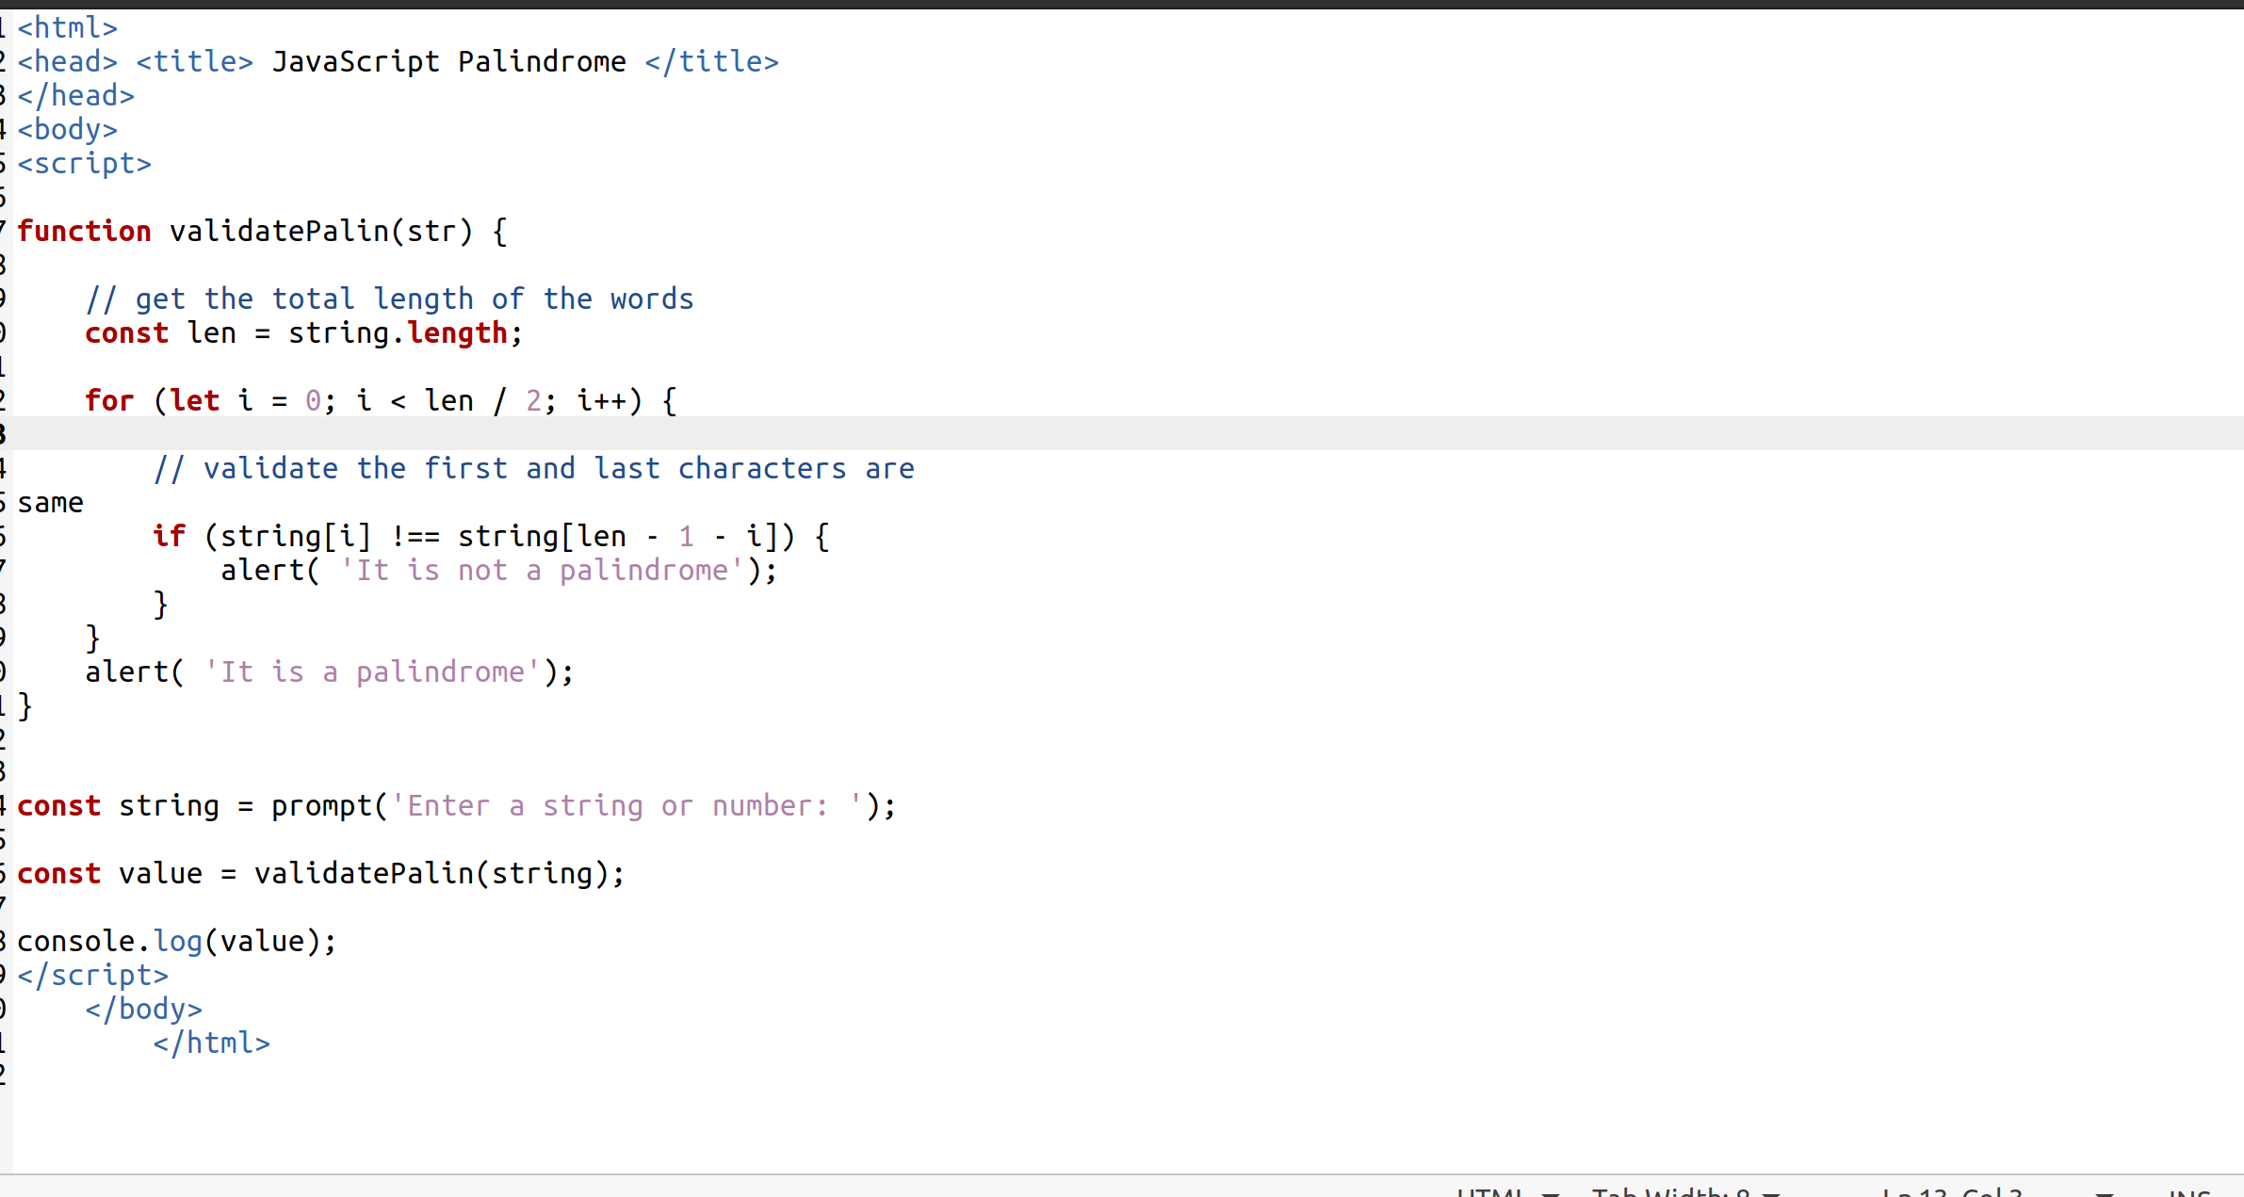

OUTPUT :

